The impact of rural road supported
By the Poverty Reduction Fund Project (PRF)
(October 2018)

Prepared By: Hatthachan PHIMPHANTHAVONG
Data Collection: Khamtue VONGLORKHAM
PRF M&E Provincial team

Rural road sub-projects contribute to improving the living conditions of villagers in rural areas. They assist in the marketing of agricultural products by enabling improved access to outside markets and traders. They also improve access to social services including health and education, and link villages to other village and district and provincial towns. The impact of rural road improvements is immediate and significant, especially in previously non-accessible areas. To better understand how communities have benefited from road investments the PRF Monitoring and Evaluation team, with provincial and district staff and kum ban (sub-district) facilitators, conducted a study on the impact of PRF’s rural road improvement sub-projects during August to September 2018. The team used the same target as the Road Maintenance Group (RMG) pilot which was 54 roads which PRF supported in 2017. The study focused on travel time before and after the completion of the road improvement sub-projects when travelling by motorcycle and other vehicles. The reported one way travel times from the village to the main road or to the main agricultural production areas are provided in Table 1 below:
Table 1: Reported one-way travel times before and after in 7 target provinces of PRF
Provinces | # Sub-projects | Average time  before (Minutes) | Average time after (Minutes) | Average time saving (Minutes)
Huaphanh | 9 | 150.00 | 111.67 | 38.33
Luangnamtha | 2 | 70.00 | 42.50 | 27.50
Luangprabang | 13 | 103.08 | 31.92 | 34.23
Oudomxay | 5 | 84.00 | 12.00 | 71.00
Pongsaly | 9 | 48.33 | 17.56 | 30.78
Salavan | 5 | 42.00 | 19.00 | 23.00
Savannakhet | 11 | 149.09 | 94.09 | 55.00
Overall | Total = 54 | Ave. = 102.50 | Ave. = 52.83 | Ave. = 40.69
Source: PRF, Monitoring and Evaluation Division, September 2018

During the discussion, a mixed group of 6 to 10 persons including women, men and village leaders was asked to estimate one-way, wet season travel times from the village to the main road or village to main agricultural production areas before and after completion each of the road sub-projects. Groups were also asked about impacts on marketing, household income and access to basic services), the above table indicates that villagers would save an average of 40.69 minutes to travel from the village to the main road, or from the villages to the center of the kum ban production areas as a result of the road improvement. This study also indicated that beneficiary communities were better able to access basic services as well as reduces the time to reach a dispensary or health center. Most notably, the improved roads were reported to have contributed to household incomes as households were able to more easily transport their agriculture products to markets and nearby villages.
One of the good examples: at Nammy Village, in Viengkham district of LuangPrabang province, the community reported that before the road was improved, it was very difficult to travel and that access was only possible in the dry season by foot when it took approximately 2 hours to reach the main road. The former road had no drainage, many potholes and very steep and slippery slopes. Prior to the sub-project the villagers not were able to transport their agricultural products to nearby markets, and when people were ill the trip to the health center took many hours. In 2017, PRF supported road improvements including excavating new drains and installing culverts. Now transportation by vehicle from the main road is not more than 30 minutes and villagers save approximately 1 hour and 30 minutes. Villagers reported that they can now bring their agricultural products to sell in nearby markets, and can easy travel to the health center when are ill and receive timely treatment. This was particularly important for the health of pregnant women and young children (attested by direct beneficiaries from the sub-project).
However, the sustainability of the benefits of road improvement sub-projects is a challenge for the community because of the low costs of construction and the impacts of heavy rains in the wet season. Adequate, regular maintenance work is essential for sub-project sustainability. This is the responsibility of community and the district administration. In these 54 villages, PRF has assisted the villagers establish an operation and maintenance committee PRF (by setting up the Road Maintenance Group or RMG) to ensure proper maintenance of the road after completion of the road improvements financed by the project and to provide to the most vulnerable households the opportunity to get regular cash income in return for contributing labor for road maintenance.
Nammee village, Viengkham district,
Luangprabang province
RMG members are maintaining the road

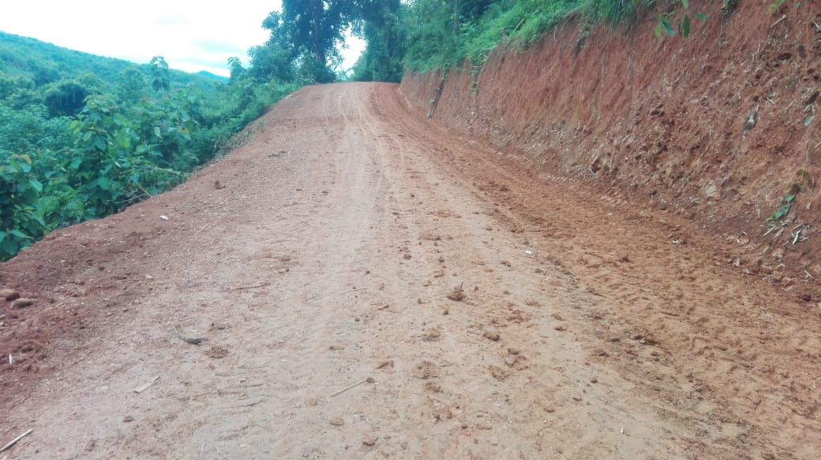
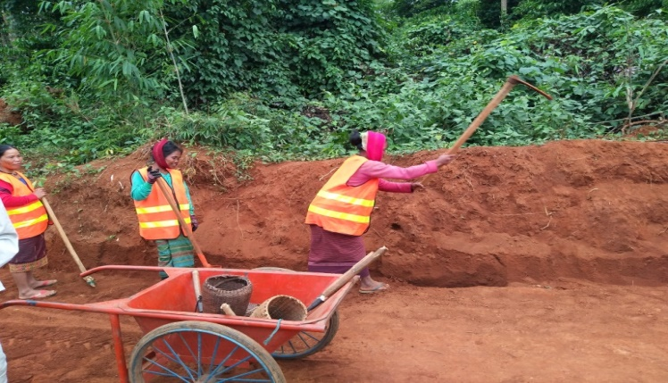

Note that the road sub-projects aimed to improve access to the main road while others aimed to improve access to farmer fields.

