Initiative on Poverty Reduction in East Asia
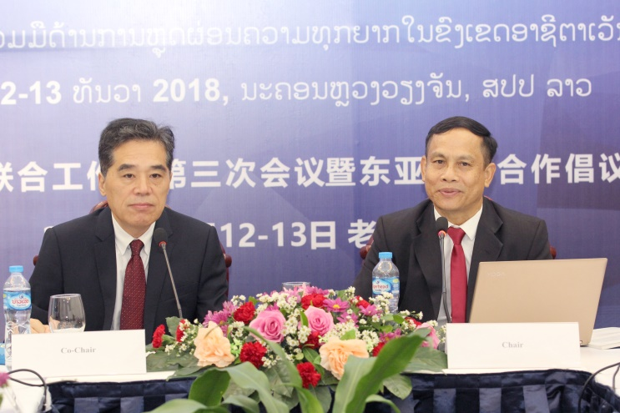
On 12 December 2018, Department of Rural development and Cooperative, Ministry of Agriculture and Forestry held the 3rd Joint Working Group meeting on Poverty Reduction for Lanchang-Mekong Cooperation and Seminar on Cooperation Initiative on Poverty Reduction in East Asia, which was co-chair by Mr. Chit Thavisay, Executive Director of Poverty Reduction Fund and Mr. Tan Weiping, Director General of International Poverty Reduction Center in China and participants from Cambodia, Myanmar, Thailand and also from Lao PDR around 30 people.
The purpose of this meeting is to review and sharing experiences on how to make the joint note cooperation more effective.
The participants reported the experiences of China-aide Pilot Project of Poverty Reduction Cooperation in Myanmar, Progressive Report on poverty Reduction through Rural Economic Development under Lanchang -Mekong Cooperation in Cambodia, Thailand’s Poverty Reduction Approach Reduce Expenses, Increase Income, Expand Economic Opportunity as well as China–aide Pilot project of Poverty Reduction Cooperation in Lao PDR.
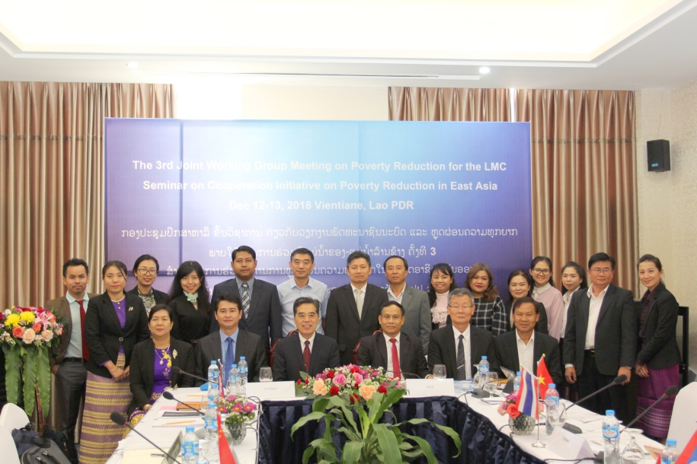
This is meaningful meeting, participants have exchanged experiences each other on poverty reduction in East Asia deeply especially mentioned the lives condition of the villagers who make a living along the Mekong River and the way to improve their infrastructure.
However, poverty reduction in East Asia there are challenges to pay attention as natural disaster (flooding), differences of educational level of targeted group will limit in transferring technical skills, to follow up the community- based business activities, encouraging the people to produce local products using their homegrown skill and expertise, providing technical assistance and advice to enable them to produce their goods more efficiently and of higher quality that reach world standard and marketing their goods throughout the country and around the world. In addition, Community Driven Development Approach performed by Poverty Reduction Fund (PRF) also is challenge but it can make communities accessing and prioritizing what they need for their community to proper builds both a common vision for a better future and their ability to work effectively together.

