Swiss delegation assesses PRF projects in remote villages

By Katharina Bracher

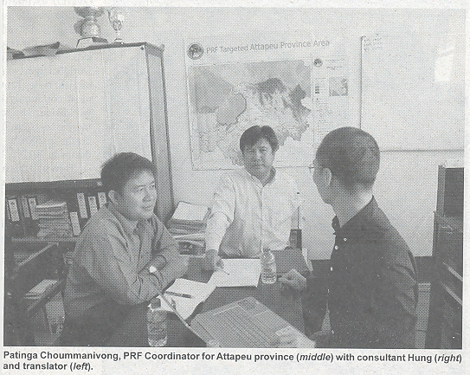How can the poorest citizens in remote areas be encouraged to take their fate in their own hand? And how can they contribute to their integration into Lao society and have their share on education and economic growth? There are two questions that the Lao Poverty Reduction Fund (PRF) seeks to answer since its founding in 2008. They have made progress not just by funding infrastructures such as schools, roads and dispensaries, but also by introducing the CDD-approach (community driven development), where villagers decide for themselves, which infrastructures they need most. They do so by attending regular meetings and voting on projects in question.
To assess the success of the CDD-approach, a delegation of Swiss Agency for Development and Cooperation (SDC) recently met authorities on province and district-level in Attapeu and Luang Phabang to evaluate the progress in fighting poverty. SDC is one of the main contributors to PRF. Since its first commitment in 2010 the Swiss Government has spent $ 23 Million to fund PRF-projects. Before the end of the second phase of PRF, SDC is carrying out a study to evaluate beneficial effects as well as existing challenges still to be overcome. “We are happy to have our projects evaluated by the SDC-team and hope to benefit from their appraisal by improving our work”, says Ai Sengphet Vannavong, Head of PRF-Community Development Division, PRF.
During their visit in late December, the delegation learned about the progress made in villages in Phouvong district, Attapeu province and the remote village of Phoupod in Chomphet District, Luang Phabang province.
They interviewed PRF staff at the provincial and district level as well as village group (Kumban) development leaders and villagers benefiting from the Poverty Reduction Fund.
The community-driven development approach enables communities to decide self-reliantly about infrastructures and sub-projects, contribute to implementation and maintenance, and take responsibility for sustainable financing.
“Community-driven development has been adopted to make sure the Poverty Reduction Fund is supporting infrastructure projects that best reflect the needs of the villagers,” says Pham Thai Hung, leader of the delegation and a consultant from Vietnam, who is currently assigned with SDC.

A key principle of the Poverty Reduction Fund is the social inclusion of women and ethnic groups in decision making.
“The aim is to have more vulnerable groups participating in the planning and development of their infrastructures,” Hung says.
The Fund has adopted this strategy for local development by mandating participatory planning processes at the village level, in which all community members - regardless of their poverty status, gender and ethnic background - are invited to village planning meetings to identify their needs and prioritise investment.
“To make sure that the most marginalised groups such as women or poor non-Lao Tai have their vote count, beans and stones are used for prioritisation," explains Hung, who is also a recognised expert in his country when it comes to the subject of integrating the most vulnerable groups into society.

The SDC team had meetings with PRF staff in Attapeu province to assess how the community-driven development guideline was implemented.

“We train local government and community volunteers to share their knowledge with the villagers,” PRF Coordinator for Attapeu province, Patinga Choummanivong, tells the visitors.
They have also distributed posters with pictures to explain the process of decision-making and participation to illiterate people and non-Lao Loum speakers.

The SDC team has already been able to evaluate the effects of community-driven development implementation.
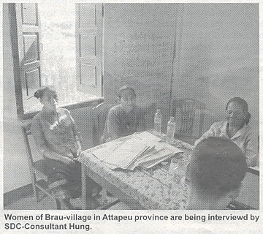“More than 52 percent of villagers attended annual planning meetings in 2014 and interestingly around 46 percent of them were women and 66 percent belonged to ethnic groups,” Hung says.

PRF plans to take this success forward by first organising smaller meetings with different groups of households before the actual village meeting, where all the villagers will be present to discuss their needs and prioritise their investments.

“Like this we hope to ensure that the poorest people will discuss and agree on their needs, so they can speak with one voice at the village meeting,” Sengphet says. He is convinced that even the poorest, non-educated citizen can decide on their fate - provided that they have information available, they can fully comprehend. Sengphet uses an analogy to elaborate his thought: “Even an elephant can draw a picture. All it needs is a brush and someone who directs its trunk”, he says.

